Plot Control Dialog

Selecting the View → Plot Control... item:

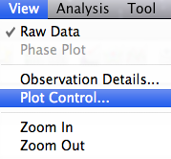

opens the plot control dialog. The example below shows the Plot Control Dialog resulting from an AID load of R Car.

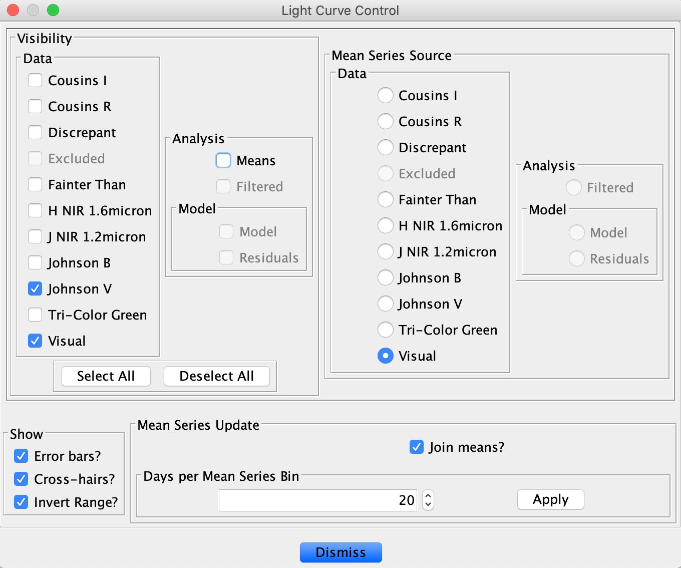
The dialog has a few distinct features:

- Visibility checkboxes. Toggling these immediately changes the series that are visible on the plot and in the observation list. Select All and Deselect All buttons make it easier to work with many series.

- Mean series source radio buttons. Selecting a radio button changes the series that is used to create a mean series. If the mean series is not already visible, changing this selection makes it so. A mean series source change is acted upon immediately.

- Checkboxes for:
  - showing/hiding error bars;
  - showing/hiding cross-hairs;
  - inverting the range axis.

- Binned mean series update:
  - Checkbox to join mean data points.
  - Spinner and text-box for number of days or phase steps per bin. The Apply button must be clicked for a change to this value to be acted upon.

The first two sections vary according to the number of series in the currently loaded dataset.

If the Means checkbox is selected as follows:
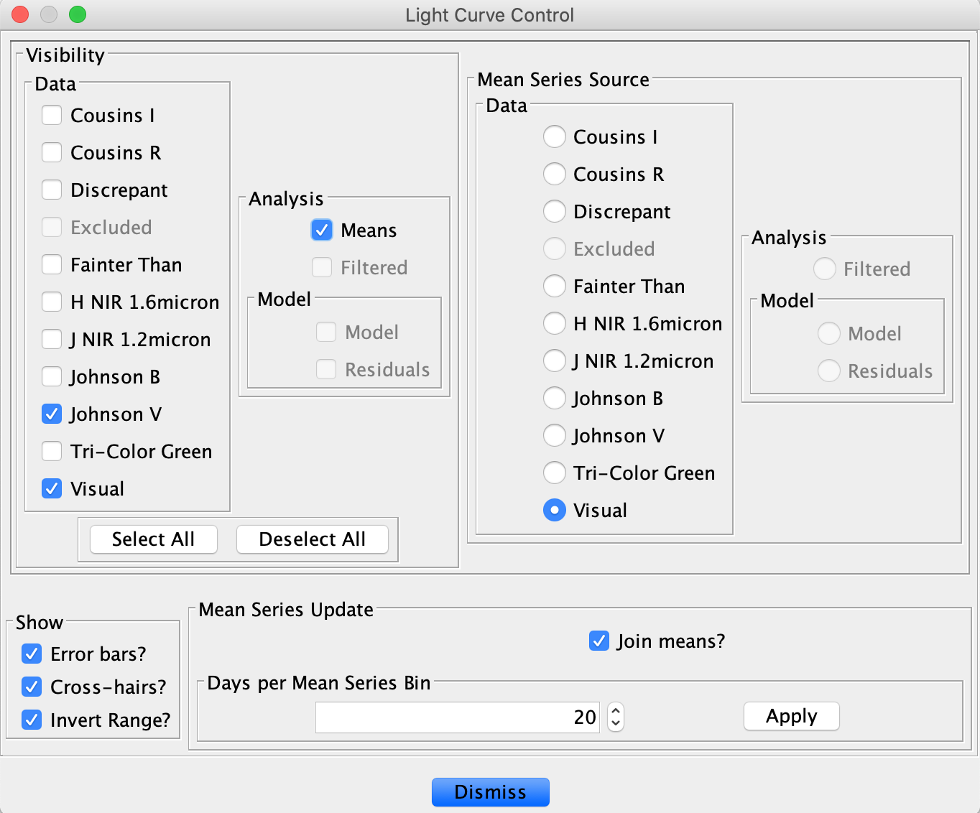
the resulting plot will look somewhat like this, depending upon JD range loaded:
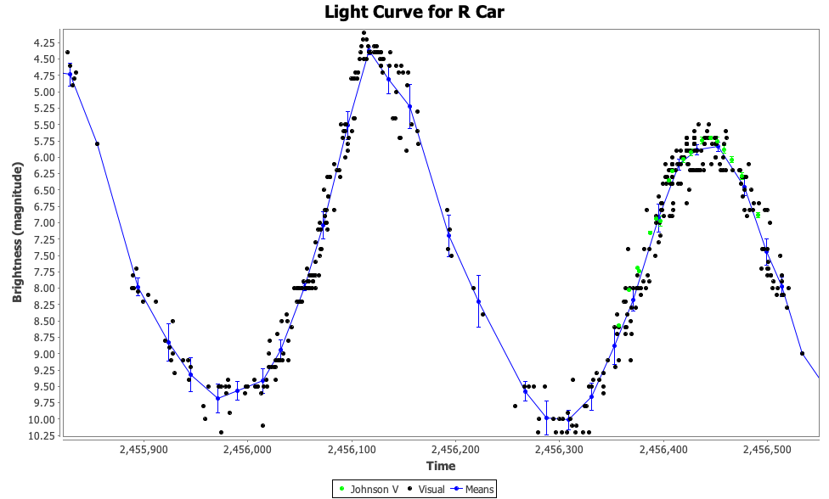

When in Phase Plot view mode, the Mean Series Update section changes to refer to Phase steps per Mean Series bin instead of Days per Mean Series bin as shown below.

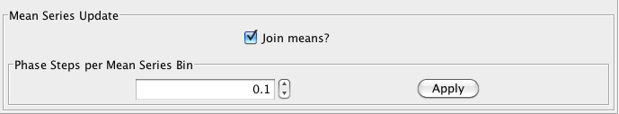

The resulting phase plot (after clicking Apply) would look somewhat like this:
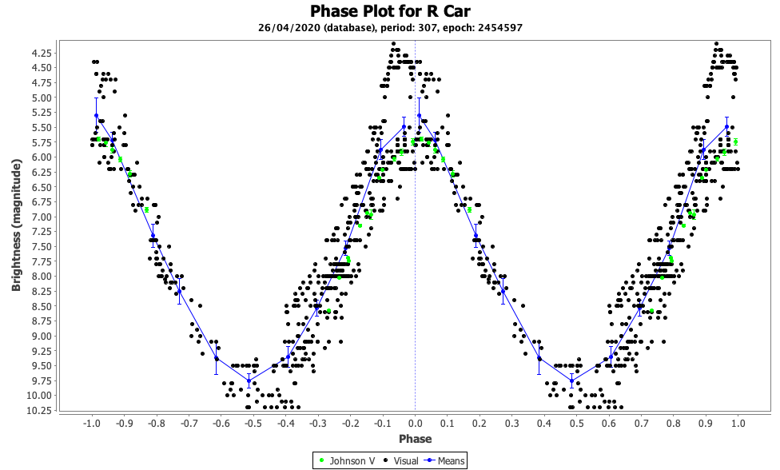

Note that for the mean series, error bars denote 95% Confidence Interval (twice Standard Error).

